

**NATIONAL UNIVERSITY OF SCIENCES AND TECHNOLOGY**

School of Electrical Engineering and Computer Sciences

**Advanced Programming**

**ASSIGNMENT - 01**

**(CLO-1)**

**Title of Assignment: Exploration of OPEN SOURCE SOFTWARE.**

**SUBMITTED TO: Dr. Sidra Sultana.**

**SUBMITTED BY: ABDULLAH.**

**CMS ID: 207515.**

**CLASS + SECTION: BSCS**- **7(A)**

**Date of Submission: 16/09/2019.**

**Open Source Software: *October CMS.***

Installation & Configuring:

Download the package, unzip it and paste it in the new local server subdirectory i.e. 

Then, grant all the permissions of the installation directory, its subfolder and files. Navigate to the Install.php script in web browser and install October by following installation instructions.

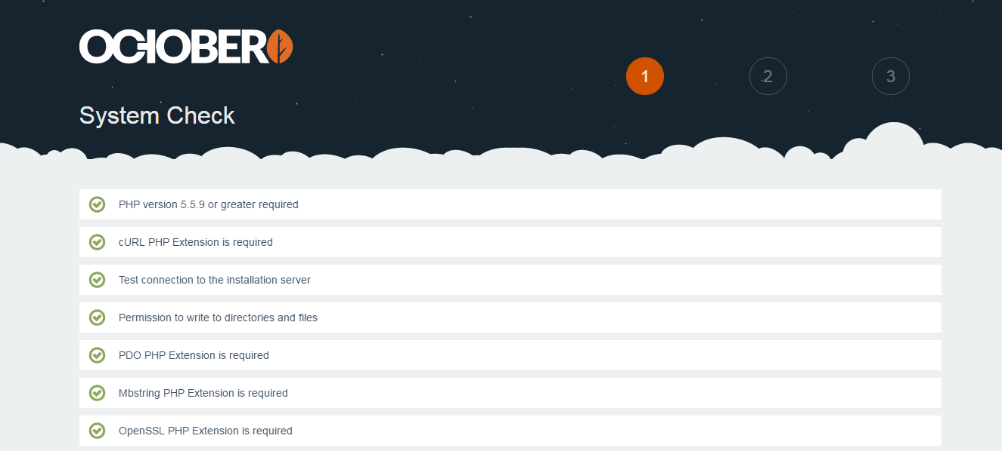

For configuration, start filling the empty fields for General, Database, Administrator, Advanced Options.

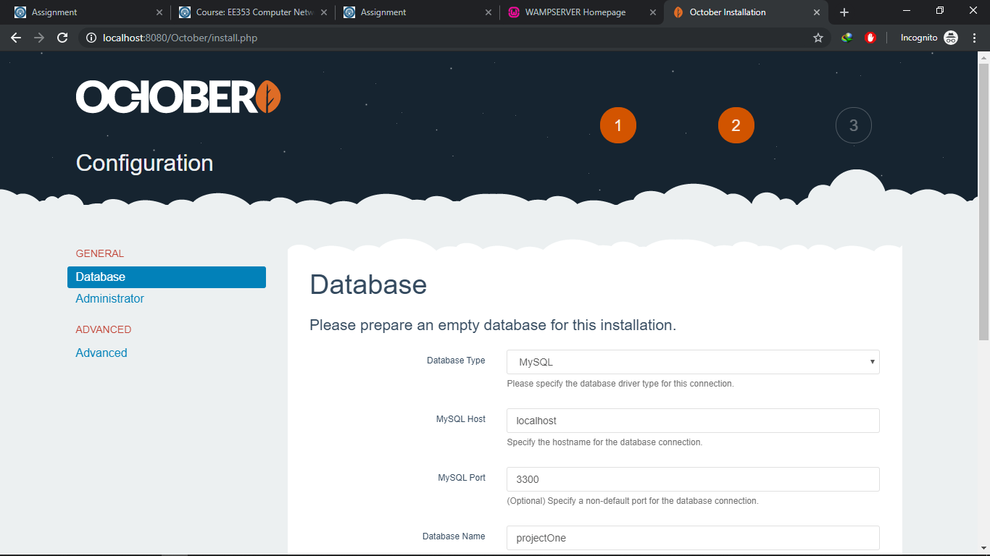

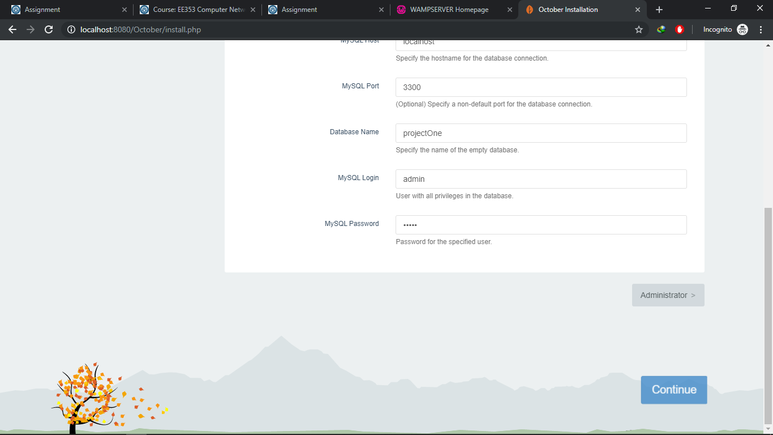

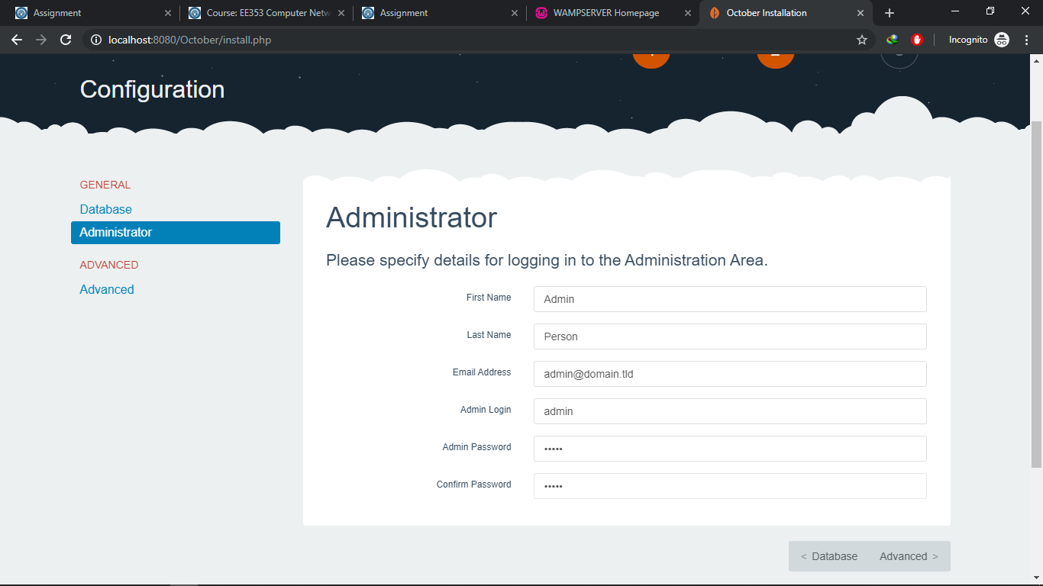

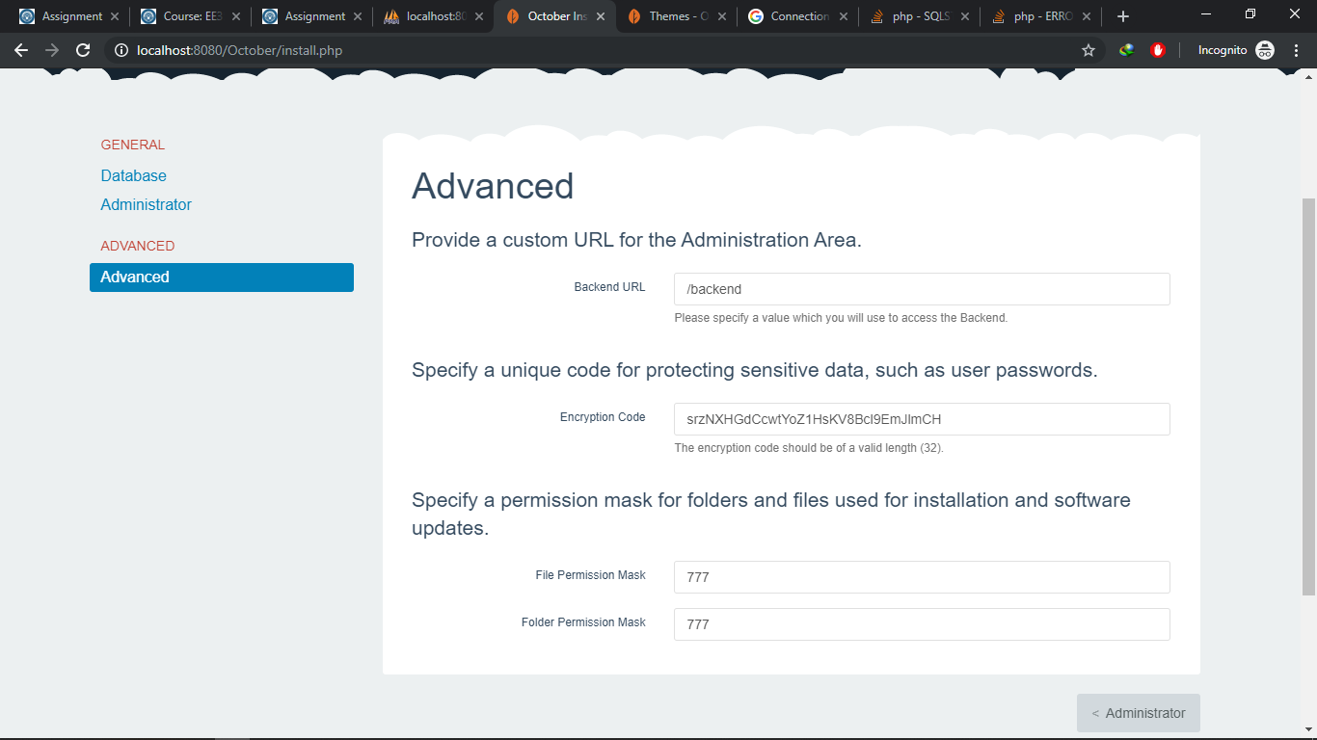

Configuration Completed.

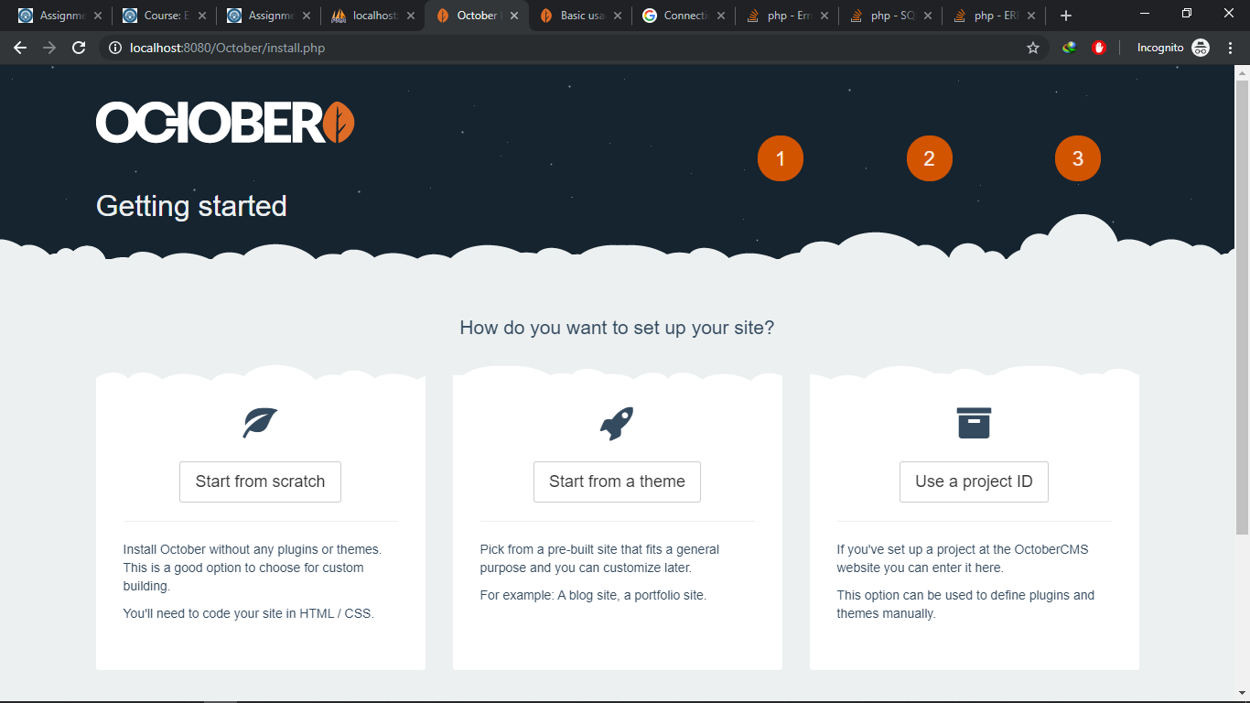

**Exploration as a User:**

* **Dashboard**: Main Page a User see when he/she login to Backend Panel of the October. 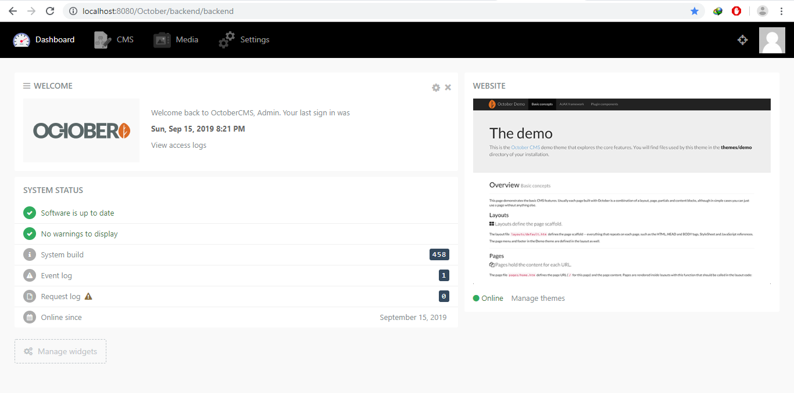
* **CMS:** Here user decides theme and appearance of the website built by October. Through CMS, user can manage all the components of the website such as Pages, Partials, Layouts, Contents and Assets.

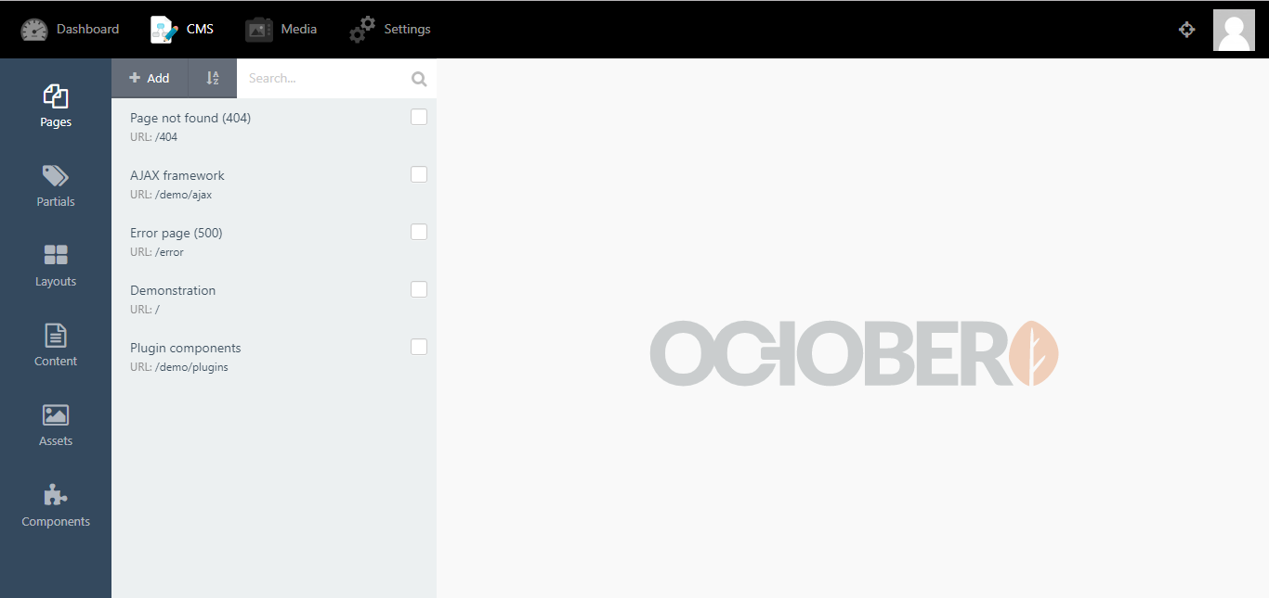

1. **Pages:** contain the pages of website.

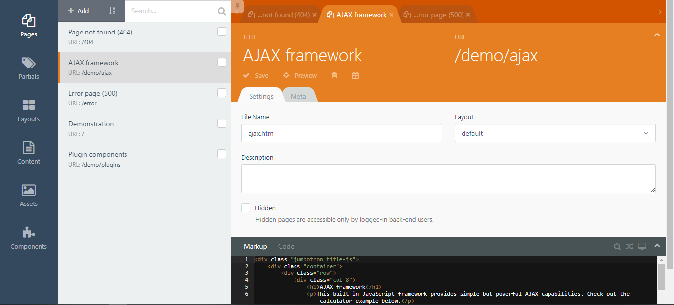

1. **Partials:** contain the reusable chunks of HTML Markups.

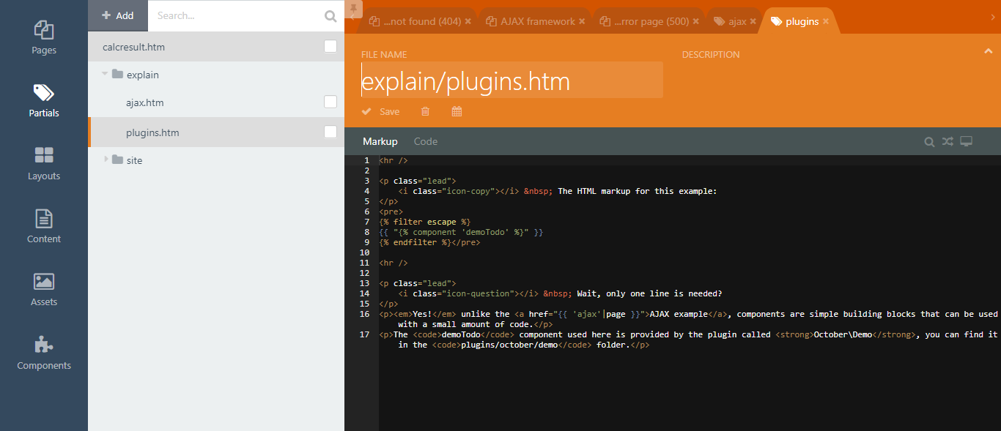

1. **Layouts:** contain the design pattern of the web-pages.

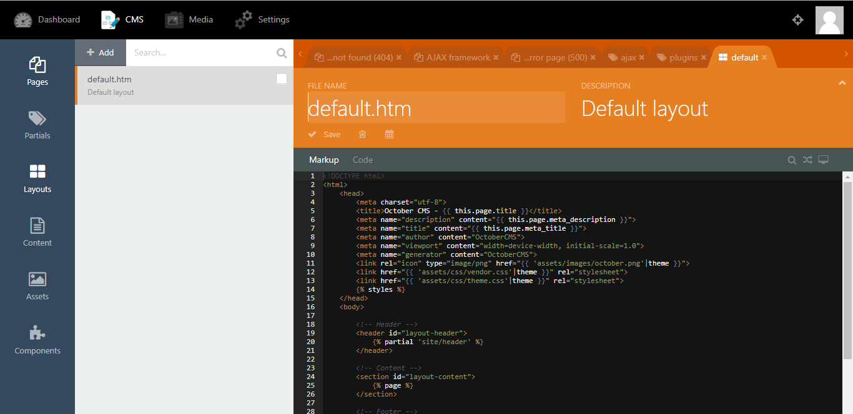

1. **Content:** contain the reusable text, HTML, or Markdown blocks that user want to edit or change separately from the page or layout.

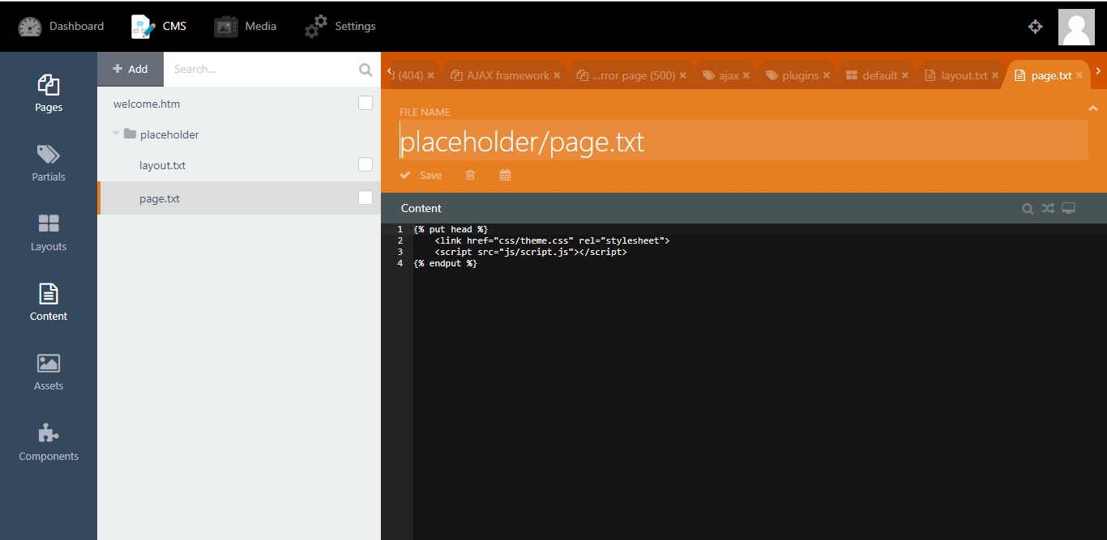

1. **Assets:** contain all the necessary files like HTML, CSS and JAVASCRIPT and other resources.

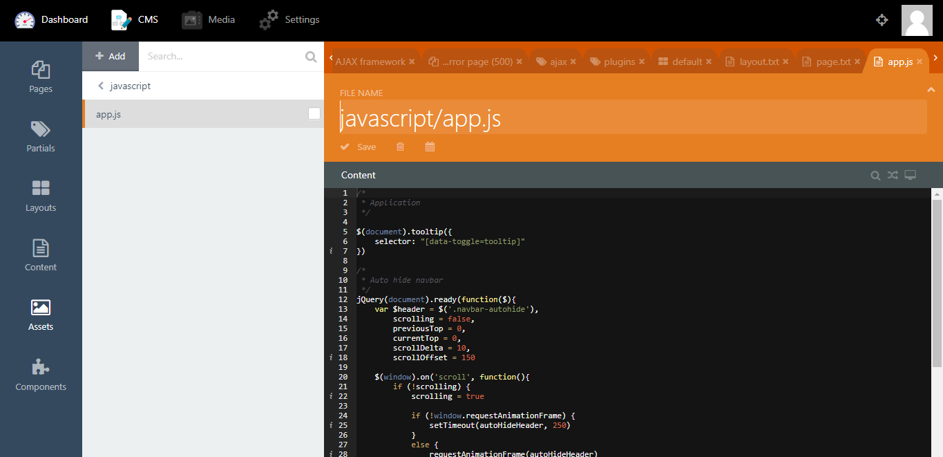

1. **Components:** use to handles the AJAX requests, page execution cycle, form postbacks calls and security of the website.

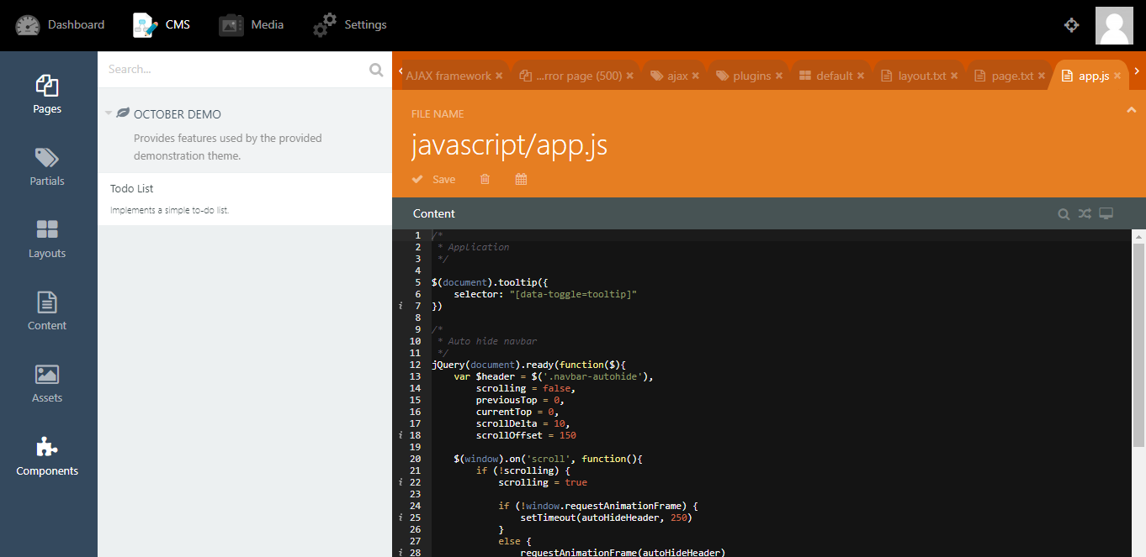

* **Media:** contain everything related to Media such as Videos, Images, Audios and Documents. Here, user can manage all media files add, remove and edit them.

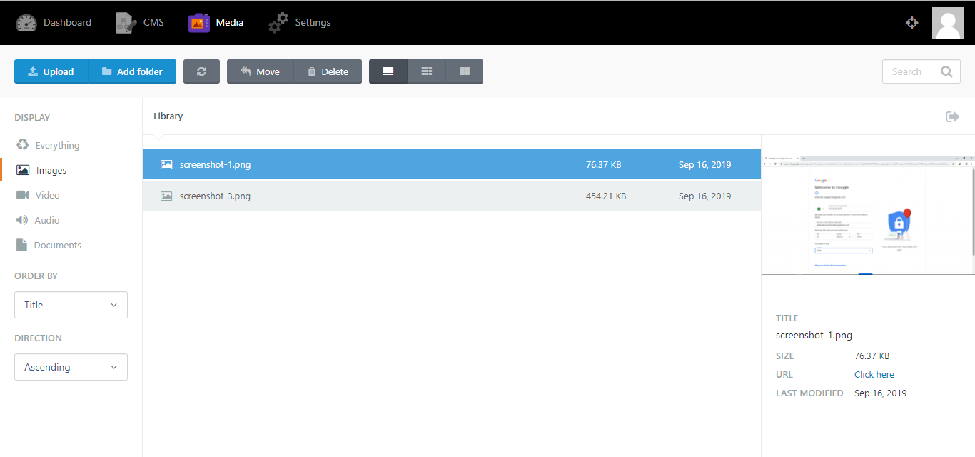

* **Settings:** provides the required services to the user to edit, toggle and manage the websites settings. It includes manage front-end theme, configure the web into maintenance mode, system management, mail adjustment and control the event logs.

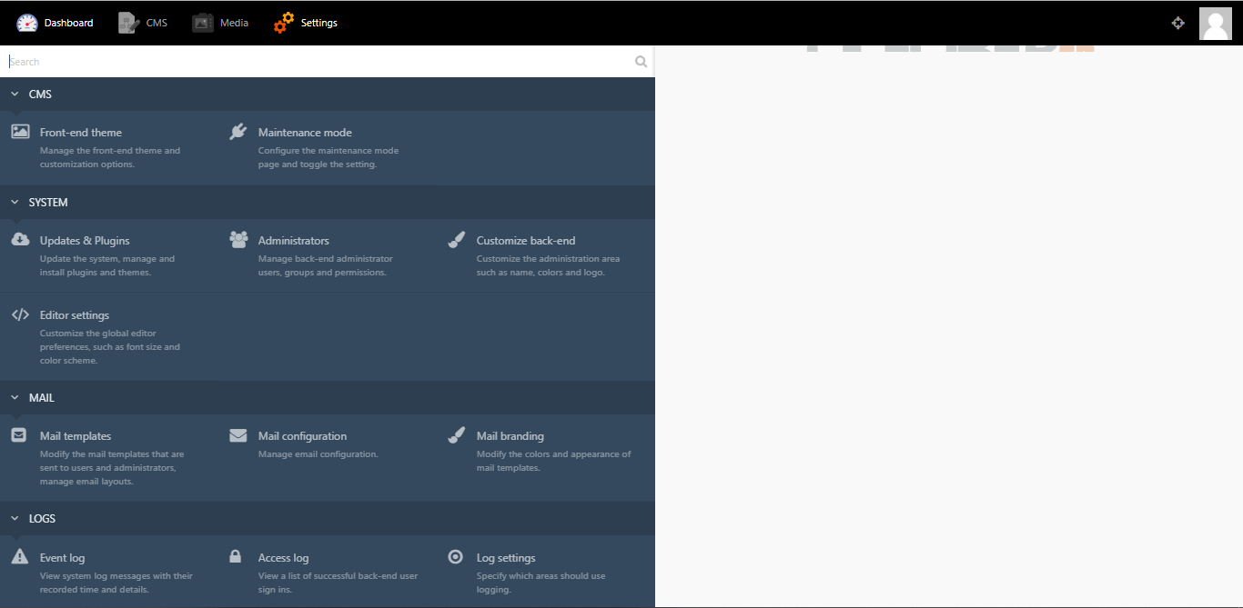

**Database:** This is the database of the October CMS where you can manage all the information, create new or delete old ones manage every entity or table of your website through php server.

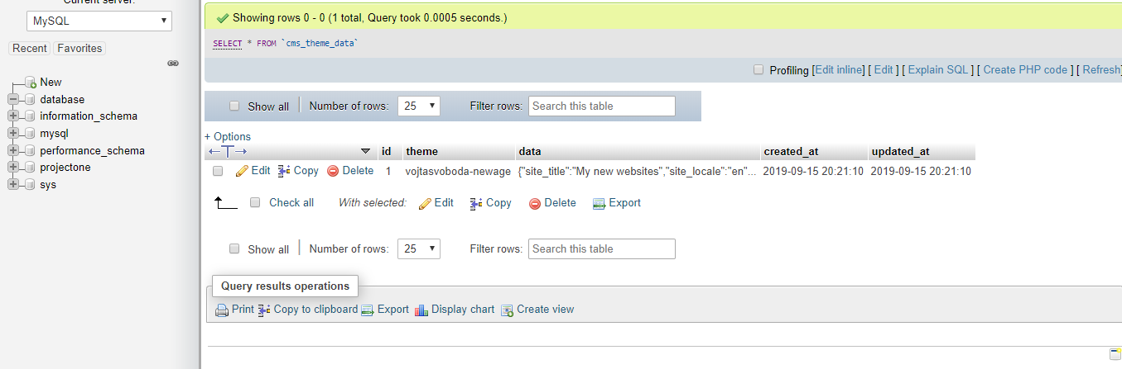

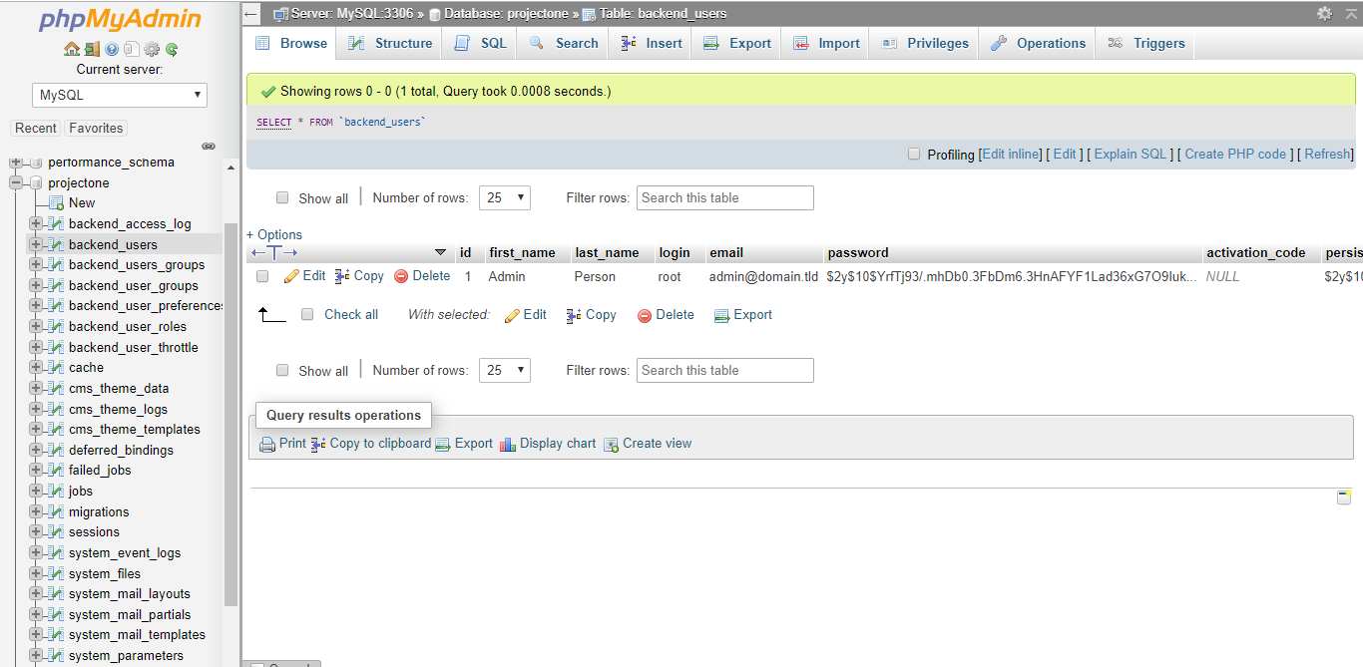

**Coding Structure:** Install_files contain all source files like scripts, php, css and other resources. User can manually edit, toggle and update these files.

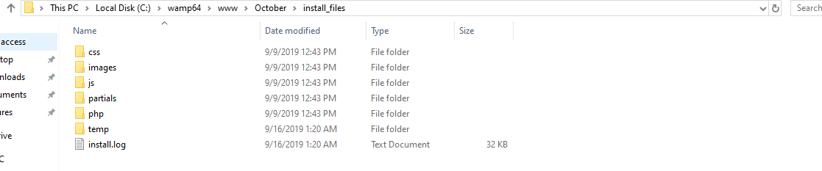

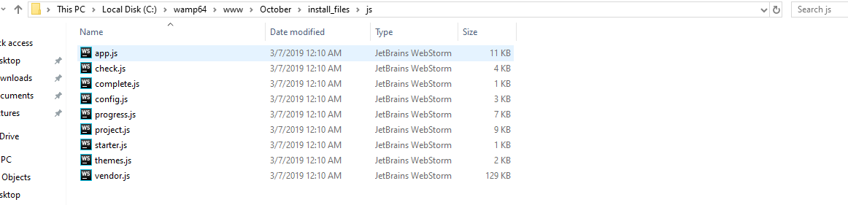

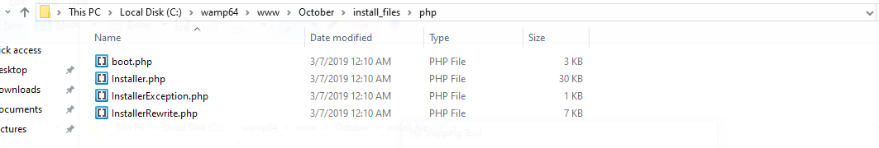

**Themes:**

I choose second option which says “start from a theme” i.e. a pre-built site that fits a general purpose and you can customize later. Then I choose a theme and start Installing it.

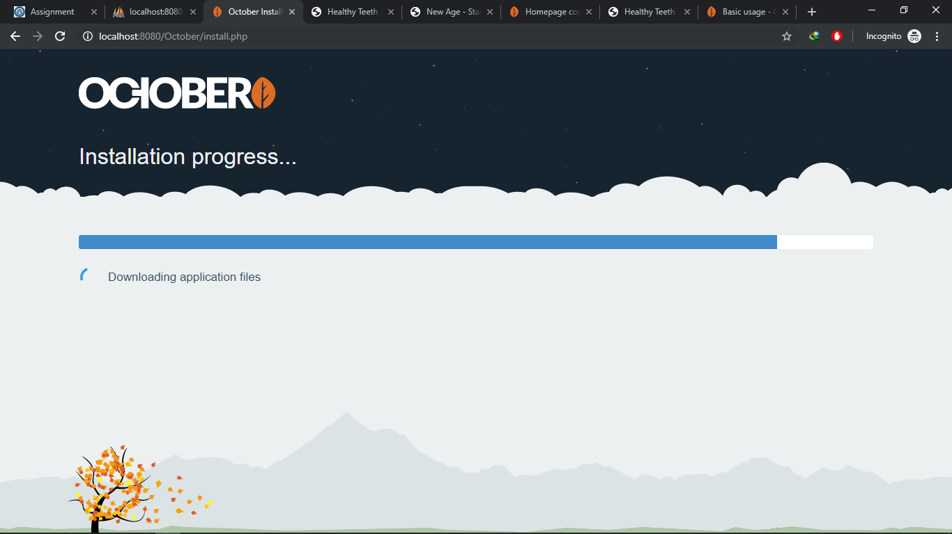

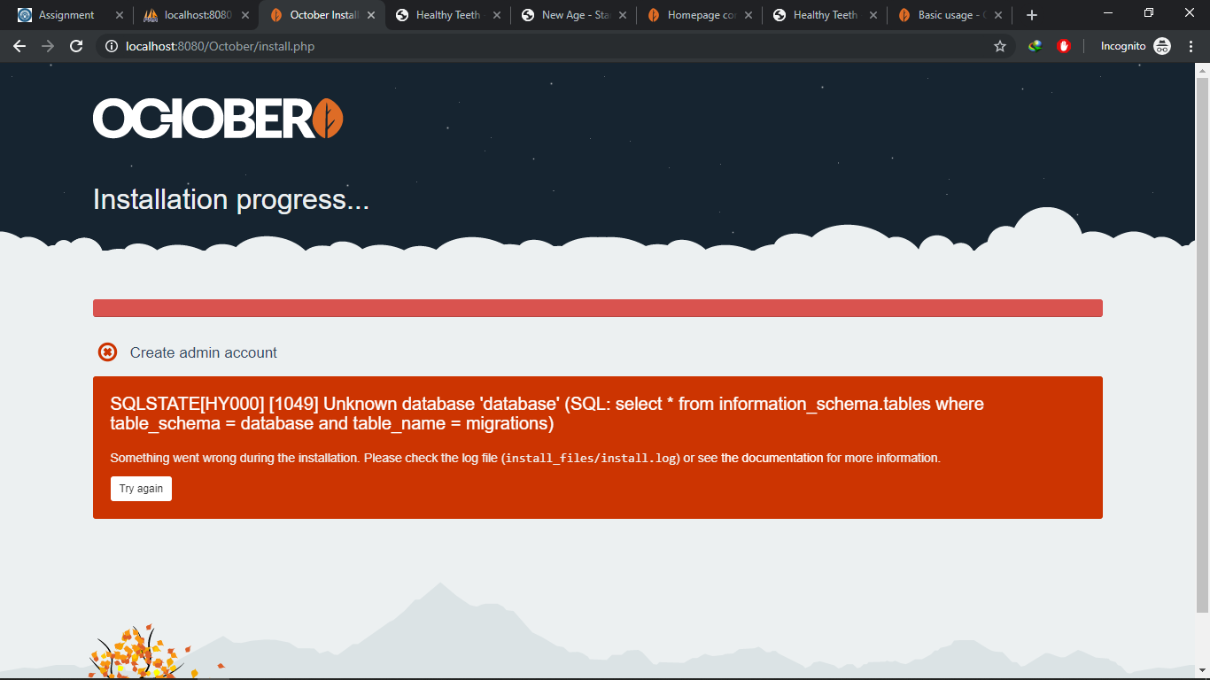

An Error occurred before an installation completed which I searched on google, found its solution and fix it.

